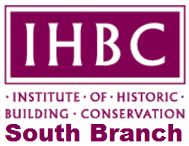

**IHBC South Branch Summer Seminar**

**The Only Way is Ethics!**

Friday 14th July 2017, Examination Schools, High Street, Oxford

BOOKING FORM

Full Name: ……………………………………………………………………………………………...

Company/Authority: …………………………………………………………………………………...

Contact Address: ………………………………………………………………………………………

Contact tel. no: …………………………………………………………………………………………

Contact email: ………………………………………………………………………………………….

Please book me: ……………..(no.) Member Place(s) at £35 each.

Mem. no(s) …………….……………………………………………………………………………….

Please book me: .............(no.) Non-Member Place(s) at £50 each

**PAYMENT** (please complete/delete as appropriate).

• I will send a cheque for £............... made payable to IHBC South Branch

NB: If you intend to pay by cheque, you will be given the appropriate postal address to send this to at the time of booking.Please ensure you give your surname as the reference on the back of the cheque

• Please invoice me via:

Contact Name/Organisation/Payee:...............................................................................

Order Number (if required): ...........................................................................................

**Please tell us if you have any special dietary or access requirements:** ...................................................................................................................................................

**Please note that there is no parking available at the venue. Please arrange to use appropriate public transport, the city Park and Ride or park in one of the city centre car parks.**

**Please return this booking form as soon as possible (and by Friday 23rd June) by email to** [**southbranchsecretary@ihbc.org.uk**](mailto:southbranchsecretary@ihbc.org.uk)