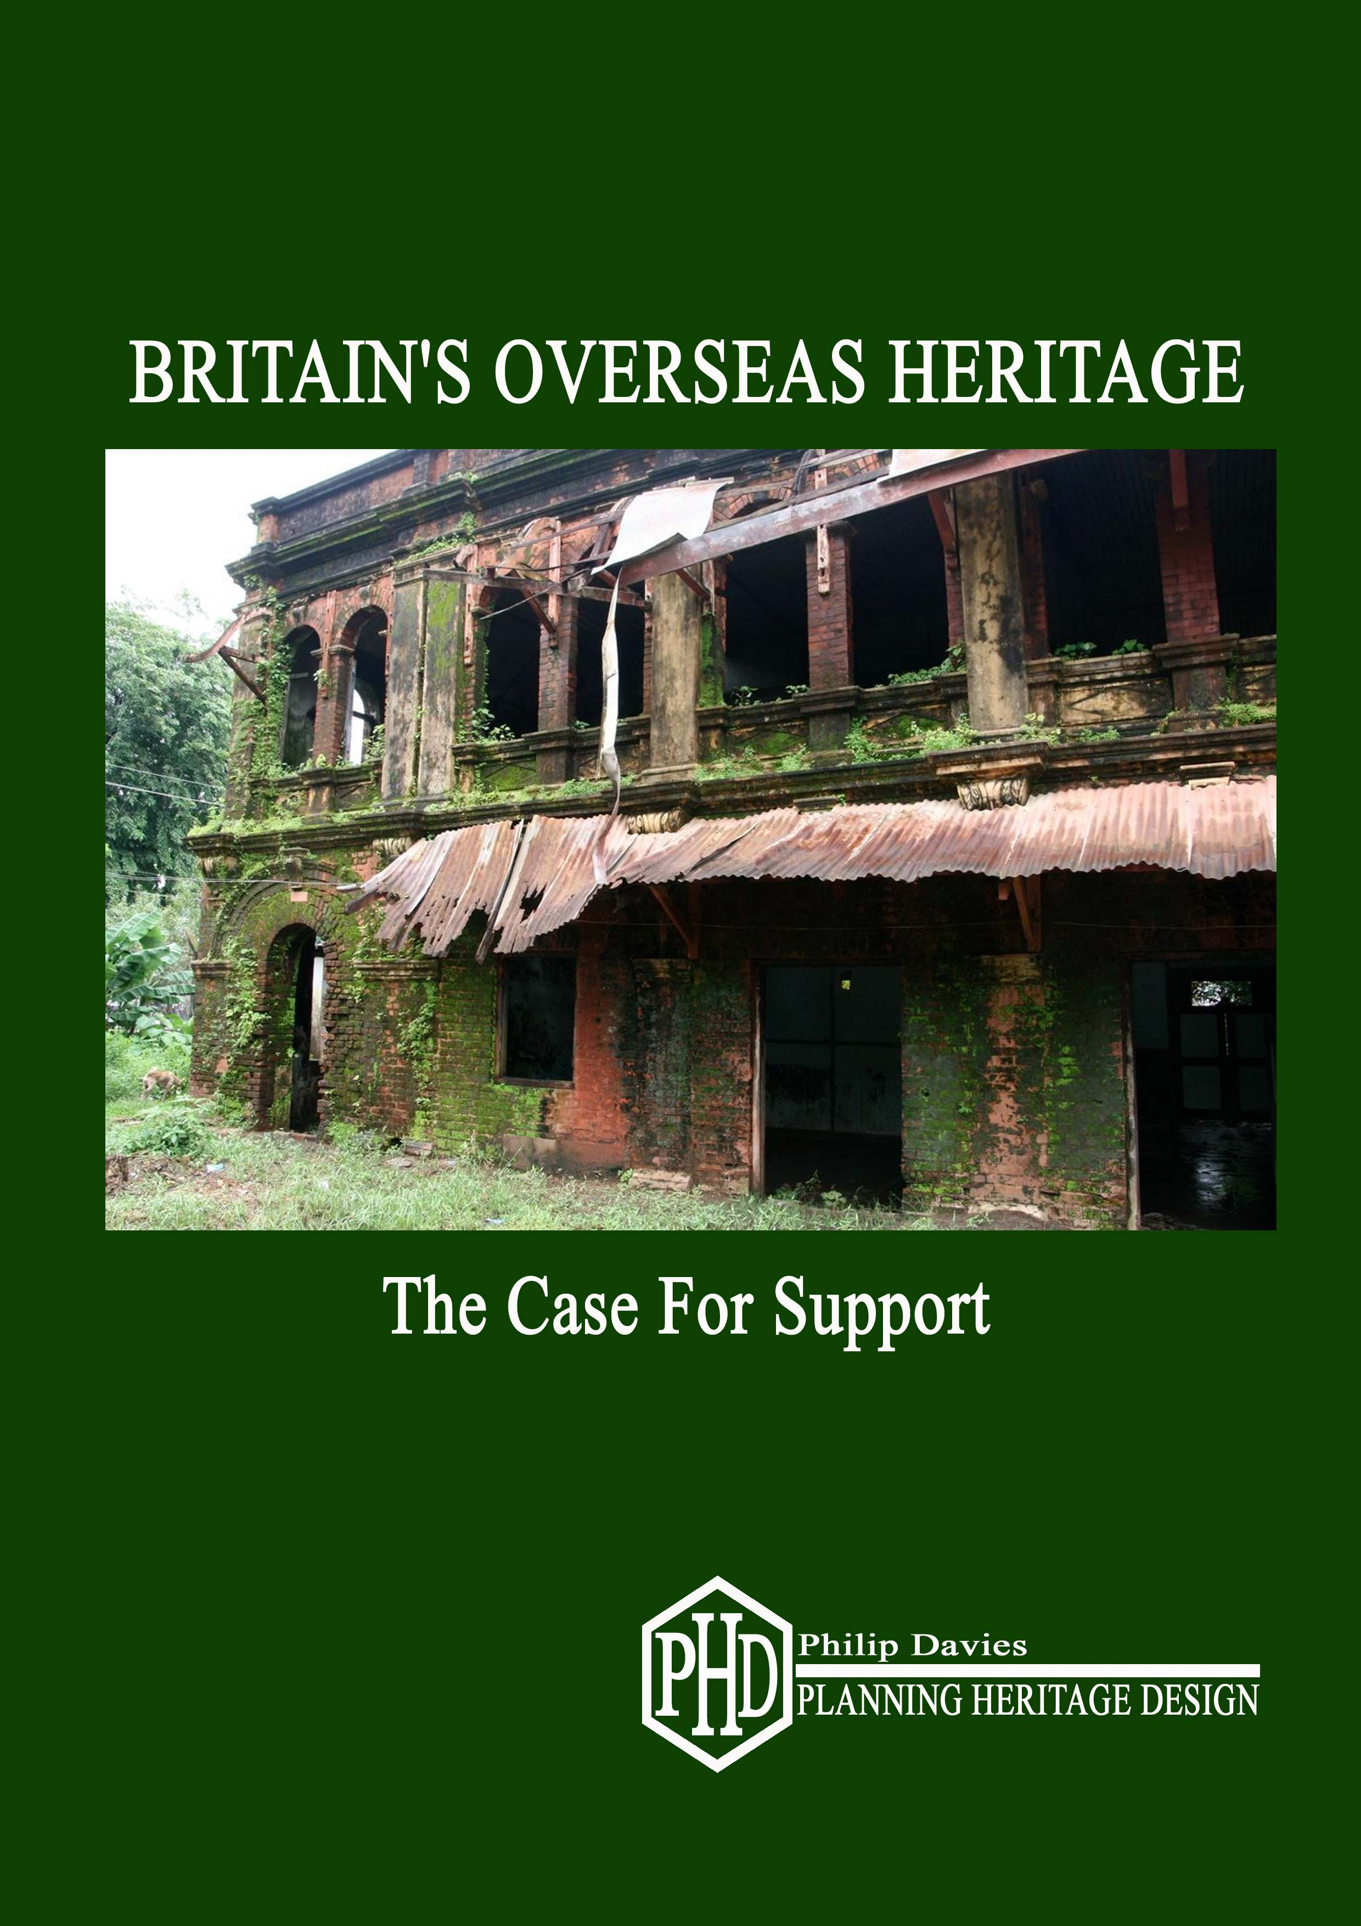

# BRITAIN’S OVERSEAS HERITAGE

# THE CASE FOR SUPPORT

*“Beautiful and ancient buildings … are not only historical monuments of supreme value, but are part of the spiritual and aesthetic heritage of a nation”*

*Lord Curzon*

**Philip Davies (Heritage and Planning) Ltd**

**March 2016**

**CONTENTS**

**Preamble**

**Summary**

**1.0 Background**

**2.0 Options for Support**

**3.0 Disbursement**

**4.0 Recommendations**

**Preamble**

## Philip Davies (Heritage & Planning Ltd)

Philip Davies MA (Cantab), DipTP, MRTPI, IHBC, FRHistS, FRAS, FSA is the principal in Philip Davies (Heritage & Planning) Ltd, a consultancy specialising in conservation, urban design and planning issues in the UK and overseas. From 2004-2011 he was the Planning and Development Director for London and South East England at English Heritage responsible for two multi-disciplinary regional offices plus the Government Historic Estates Unit, which provided advice and guidance nationally across the entire government estate, including the occupied royal palaces, Whitehall, Defence Estates, and the Palace of Westminster. He has prepared national guidance on a whole range of heritage issues from tall buildings and heritage at risk to the public realm, the management of conservation areas and the constructive conservation of listed buildings.

He has over 40 years' experience of managing change to some of Britain’s most sensitive historic buildings and places. He is a Trustee of the Heritage of London Trust, and the Euston Arch Trust, a committee member of SAVE Britain’s Heritage, and a member of the Advisory Panel of the UK Railway Heritage Trust.

He has been actively advocating the conservation-led regeneration of Kolkata for over 40 years and has given presentations to many conferences and seminars in the city over that period*.* Following a UNESCO conference in October 2015, his report, *Kolkata: Time for Action* was passed to the Chief Minister of West Bengal by the UK Deputy High Commission, and discussed during a recent ministerial visit.

As an expert in colonial architecture, and founder member of the International Advisory Group of the Yangon Heritage Trust, he is currently helping to advise the government of Myanmar on a conservation and regeneration strategy for the city of Yangon where he prepared a detailed conservation management plan for the former Secretariat, the most important colonial building in the country, as an exemplar of best practice. In July 2013 he assisted the Foreign and Commonwealth Office by making presentations on heritage-led regeneration to President Thein Sein during his visit to London.

He is the best-selling author of eight major books on architecture and architectural history in Britain and overseas, and a large number of articles for both professional and popular journals. These include *Splendours of the Raj – British Architecture in India – 1660-1947, and the Penguin Guide to the Monuments of India – Islamic, Rajput and European,* the most comprehensive coverage of India’s buildings and monuments ever written. His book *Lost London 1870-1945*, short-listed for the prestigious Spears book prize, is the best-selling book on London ever published.

Over the past 40 years he has travelled to over one hundred countries researching and recording Britain’s overseas heritage for an illustrated book on the architecture and monuments of the British Empire and Commonwealth, most recently to the Falkland Islands, South Georgia and the Antarctic.

**Executive Summary**

1. This report is a response to the invitation for ideas for a new national cultural programme as part of a strategic review of the cultural, arts and heritage sectors by the Department of Culture, Media and Sport. It addresses the objective of how to promote Britain better abroad, and has been circulated *inter alia* to Historic England, Historic Scotland,the World Monuments Fund, SAVE Britain’s Heritage, ICOMOS UK, the International National Trust Organisation, Heritage Alliance, and a wide range of other expert heritage bodies and individuals.
2. Britain’s overseas built heritage is a crucial aspect of its global culture and international image, but responsibility for its support and promotion falls between various different government departments and agencies. While often it is valued and converted to beneficial new uses by individual host countries, in too many cases important buildings and monuments which symbolize Britain’s long and close relationship lie dilapidated and decaying harming Britain’s international image.
3. This report recommends that the government should introduce practical measures to assist eligible bodies attempting to repair Britain’s overseas heritage of historic buildings, monuments and landscapes as an important aspect of its global cultural reach and as a tangible exercise in soft power.
4. Four potential funding options are set out. In each case there would be no additional administrative costs. A small voluntary advisory committee of experts and nominees from interested bodies, including the DCMS, could assess submitted applications, which could be made to, and managed by, the secretariat of the World Monuments Fund, or another suitably qualified body.
5. The report recommends that a pilot project be set up in the form of a challenge fund – The GREAT British International Heritage and Regeneration Fund - for a period of 5 years to test demand and review the outcomes with measurable outputs, and that initially £2 million be made available commencing in April 2017.

**1.0 Background**

1.1 The Department of Culture, Media and Sport has issued a consultation inviting ideas for a new cultural programme, prior to preparing a strategic overview of the cultural, arts and heritage sectors for inclusion in a White Paper. One of its four objectives is the explore how our cultural institutions can promote and enhance Britain abroad, and, in particular, in our relations with other countries and international organisations, and to support trade, exports, inward investment, inbound tourism and the presentation of cultural artefacts. This short report contends that heritage-led regeneration has a crucial role to play through better measures to support Britain’s overseas heritage, which is such a visible aspect of its international image. It has been circulated to all the major heritage agencies including Historic England, Historic Scotland, the World Monuments Fund, SAVE Britain’s Heritage, ICOMOS UK, the International National Trust Organisation, and the Joint Committee of the National Amenity Societies, as well as a wide range of expert heritage bodies and individuals.

1.2 Heritage-led regeneration works. It pays real economic dividends. Historic buildings and neighbourhoods are a huge economic and cultural asset. Experience across the world - from London to Cape Town and from Penang to Hobart - demonstrates that dynamic conservation and the creative reuse of heritage buildings alongside appropriate new development, can reinforce local character and identity, and deliver jobs, skills and prosperity for all. However, in some countries conservation is not seen as a routine and profitable aspect of the sustainable development process, but as an extra cost requiring public subsidy. Through countless case studies, the UK has the ability to demonstrate how conservation is commercially viable, and that it can deliver much longer beneficial value than standard uniform new development.

1.3 People’s perceptions of a country and its culture are coloured by the way in which its global heritage is recognized, supported and celebrated. For the UK, an outstanding successful example is the Commonwealth War Graves Commission, an internationally-admired institution with a global reach and reputation, which conveys a very positive image of UK history and cultural values. Prominent public buildings and monuments, which symbolize Britain’s shared history with a host country and which are dilapidated and decaying, portray a nation unconcerned about its global culture and influence; a country in decline. Conversely active support for local efforts to repair, adapt and restore such buildings shows a country confident about celebrating its shared heritage with the world, and keen to help host countries to revive or expand their crafts and skills generating jobs, expertise, and wealth through sustainable development. Conservation is more labour-intensive and skilled than new development and therefore creates more indigenous employment and helps to build higher skills levels.

1.4 Britain’s heritage does not end at Dover. As the world’s first industrialised nation, the UK built much of the modern world, including a great deal of its infrastructure from towns and cities to roads, railways, bridges, canals, ports and dams. Some of Britain’s greatest architects and engineers designed and built overseas. The work of Sir Edwin Lutyens in India, and Sir Herbert Baker in India and South Africa is perhaps the most celebrated, but Sir William Emerson, George Gilbert Scott, John Oldrid Scott, G.F Bodley, William Butterfield and J.L Pearson all produced great buildings in India, Africa, Canada and elsewhere. Less well-known are the military engineers who built churches, barracks, dockyards, bridges, cantonments, houses and public buildings using local indigenous craftsmen. Many of the buildings and monuments they created were the product of a partnership between Britain and the local workforce. Today they symbolize a truly shared heritage.

1.5 A large number of the world’s most dynamic and prosperous cities such as Singapore, Sydney, Hong Kong, Vancouver or Auckland were founded or developed by the UK. More than any other nation, Britain has left its own very distinctive mark on the farthest corners of the earth across India, Asia, Africa, the Americas, the West Indies, Australasia, the Pacific, and even the Antarctic. As a result, some of our finest buildings and monuments of the past two hundred and fifty years can be found throughout the Commonwealth and beyond. Hitherto this has been largely ignored or disregarded, and even now is poorly researched, but with increased travel many UK citizens are now beginning to rediscover and appreciate their global heritage. This extraordinary legacy is a huge, but dormant, asset with considerable potential for expanding British influence through the sensitive exercise of soft power. At the very least, it is a highly visible manifestation of Britain’s impact on the world as a great trading nation over the past three hundred years.

1.6 This spectacular shared heritage is highly-valued by many nations as a major economic and cultural resource, not least in promoting tourism, and in bequeathing a legacy of attractive historic buildings capable of adaptation to a range of modern uses. Often it is also a key part of local national identity.

Indeed, it is a measure of the symbolic importance of cultural heritage that in the Middle East ISIL has identified the eradication of historic buildings and monuments as a key part of its radical agenda.

1.7 In many places complete streetscapes remain containing entire groups of important British buildings, which coalesce to confer a unique and distinctive sense of place, for instance, the iconic Indo-Saracenic public buildings along the Padang of Kuala Lumpur, or the great Indo-Gothic civic buildings around the Esplanade in Mumbai. Fortunately, many host countries recognise that conservation and sustainability are simply two sides of the same coin, and adaptation and re-use forms an important part of their planning and development strategies. However, that is by no means always the case. In many places, important elements of Britain’s overseas heritage are falling to pieces for want of practical support, interest and expertise from the UK harming Britain’s international image and undermining local opportunities for conservation-led regeneration. This contrasts markedly with other European countries, such as France, Spain, Germany and Denmark, which value and support their overseas heritage either through modest direct aid, the offer of specialist advice, or educational initiatives to foster local skills and expertise. Ironically many Commonwealth and other countries are far more aware of this legacy than the UK. Frequently, in the embarrassing absence of any UK lead or interest, they have stepped in to provided practical support for projects to help conserve Britain’s heritage. In Yangon, for instance, the Australian government took decisive action to help the then nascent Yangon Heritage Trust through the secondment of professional personnel. The US government has pledged $1 million from its Ambassadors Fund towards building restoration in the city. Similar support has been offered by the French. In New Zealand, the New Zealand Antarctic Heritage Trust led the way in conserving the historic Scott and Mawson huts.

1.8 Many Commonwealth countries, such as Guyana, Fiji and Jamaica have established government agencies to oversee and manage their heritage following British models, such as the National Trust. In addition to government support, across the world there are many highly effective local NGOs, voluntary trusts and charitable organisations, often operating with very scarce resources, helping to save Britain’s overseas heritage by mobilizing support through commercial sponsorship or public subscription. These range from organisations like the British Association for Cemeteries in South Asia to heritage trusts for *inter alia* South Georgia, Gibraltar, Ghana, Zanzibar Stone Town and St Helena. The lack of any UK government programme to support and encourage such bodies does little to enhance Britain’s image abroad.

**2.0 Options for Support**

2.1 Britain leads the world in the breadth and depth of its professional expertise in conservation and regeneration, but the UK has been slow in capitalizing upon these overseas, and using them to underpin a more co-ordinated approach to promoting Britain’s interests as an instrument of foreign policy. There is real export value in celebrating and supporting this. The British system of heritage protection was pioneered in India by generations of scholar administrators, long before it became a mainstream activity in the UK. For instance, Lord Minto carried out repairs to the Taj Mahal between 1807-1813. John Lockwood Kipling oversaw the wholesale revival of Indian arts and crafts, while Lord Curzon introduced the pioneering Ancient Monuments Act 1904. In India, the British founded the Asiatic Society of Bengal, the Madras Museum, the Geological Survey, the Botanical Survey, the Government Arts College and the Archaeological Survey. Great pride in these institutions is still taken across the sub-continent, but we fail to market their values, or their long shared history. Experience gleaned from overseas working can also be brought back to the UK to expand and enrich learning here.

2.2 At present, support for Britain’s overseas heritage falls between various different stools. Co-ordination is urgently needed. Wherever possible, Historic England shares its experience with interested international bodies, but it is unable to channel any funding abroad. In contrast, Historic Scotland has support for overseas heritage as one of its legitimate aims, but in practice, this has not involved any financial support. While theoretically the Heritage Lottery Fund could support such work, the overwhelming level of demand in the UK is such that it has resolved not to do so. Although the UK Overseas Aid budget has been ring-fenced at 0.7% of GDP, hitherto Britain’s overseas heritage at risk has not been seen as a legitimate priority by the Department for International Development. Foreign and Commonwealth Office interest has depended largely on the discretion or particular priorities of individual ambassadors or High Commissioners, which, while useful, is not subject to any co-ordinated strategic foreign policy objective or global overview.

2.3 It is recommended that the UK government should consider modest, but practical, measures to support requests for assistance from heritage trusts, local and national government agencies, and other eligible bodies for appropriate projects that relate directly to the effective conservation of Britain’s overseas heritage. Potential projects might cover enabling work for the restoration of historic buildings, conservation areas, monuments and memorials, cemeteries and historic landscapes, industrial archaeology and archaeological sites, and historic ships. As a general rule this could be concentrated within countries of the Commonwealth, or the former British Empire, and overseas or dependent territories, or occasionally significant sites in other countries with important British built heritage at risk. Other than in wholly exceptional cases, this probably should not involve direct support for individual building projects, but be confined to enabling work, such as the preparation of feasibility studies, conservation and development strategies, or the sharing of specialist expertise and skills using UK practitioners and consultants. Revenue funding for trusts and other bodies could be specifically excluded.

2.4 **Challenge Funding:** If a modest fund could be established, the benefits would be maximized if it operated as a challenge fund with UK government support fixed at no more than 50% of the total project cost and requiring complementary match funding from other sources. This would offer the potential to lever in resources from a wide range of other public and private sources, including private philanthropy, and ensure ownership of any project by the host country.

2.5 Support could be deployed from four potential sources:

* The Overseas Aid Budget
* The Libor Fund
* Heritage Lottery Fund
* A discretionary Ambassadors fund

**Overseas Aid Budget**

There has been considerable public criticism that at a time of austerity funds are being directed to overseas projects of marginal, if any, benefit to the UK, or indeed the recipient countries. This has led to the need for greater scrutiny and better value for money. Directing funding to legitimate projects to support Britain’s overseas heritage would offer practical help to the host country by supporting culturally-led regeneration, developing local skills, creating jobs and offering tangible opportunities for UK companies and consultants to showcase and capitalize on their expertise globally. It is much more likely to garner public support than many other projects.

**The Libor Fund**

The Libor Fund was created from the fines levied on banks by the government for unethical trading practices. While a substantial sum has been allocated to military charities, £40 million is retained by the Treasury for future deserving public purposes. Funding to support Britain’s overseas heritage, which might include the conservation of monuments and cemeteries containing previous generations of Britain’s military and civil personnel, could be seen as such an objective.

**Heritage Lottery Fund**

Given its specific aims and objectives**,** the Heritage Lottery Fund (HLF) is the most obvious source of potential funding. With government agreement, there is no reason why a small sum could not be ring-fenced each year and dedicated to support British overseas heritage under the criteria set out in 2.3 and 2.4 above. This would provide much needed help for eligible organisations, while obviating the risk of a flood of speculative applications for the direct support of individual building projects.

**Ambassadors Fund for Cultural Heritage**

A fourth option would be to allocate a modest fund to relevant ambassadors and High Commissioners to support UK cultural heritage, similar to that afforded to US ambassadors, to allow each to provide local financial support to eligible applications for assistance. Funding might be confined to areas of demonstrable need such as parts of Africa, South Asia or the Caribbean, or cast more widely.

2.6 By having the flexibility to offer modest support to deserving cases, it would offer a persuasive lever to encourage local and national authorities in the host countries to address priority historic buildings and landscapes at risk. By way of example, in India alone these might include the preparation of a conservation and management plan for the Botanical Gardens in Kolkata. Established by the British, and the oldest in Asia, they are of world importance, and also a potential major attraction, but they are currently rundown and dilapidated. In North Kolkata, the superb Silver Mint, a British building of national significance has been empty and derelict for decades. It is in urgent need of expert conservation advice, and a feasibility study to find beneficial new uses. At Barrackpore, the former residence of the Governor-General, now a derelict Police Hospital, needs a strategy for its future including the restoration of its once renowned riverside gardens, where along with the Botanical Gardens, it could act as a catalyst for linear riverside regeneration. In Hyderabad, the spectacular former British Residency, (now the Osmania College for Women), a potent symbol of Britain’s shared heritage with India, is on the World Monuments Fund’s Watch list, and in urgent need of expert assistance and support. After decades of inertia a 5 year programme of restoration has commenced, but shamefully with no practical support from the UK. In Yangon, one of the world’s great colonial trading cities, the Yangon Heritage Trust urgently needs help to save one of the finest concentrations of British commercial and public buildings in Asia. To do nothing in such highly visible cases should not be an option, and is harmful to Britain’s image and interests.

**3.0 Disbursement**

3.1 There are various options for the disbursement of potential funding. Any sum made available from any of the above sources could be assessed, allocated and monitored through existing channels. There would be no need to set up a new agency, or for expensive additional administrative costs. Whichever funding option is followed, a small voluntary advisory committee of experts in Britain’s overseas heritage could be put in place, perhaps made up from nominees from the World Monuments Fund, SAVE Britain’s Heritage, the funding partner and the DCMS, and perhaps, on occasion, invitees from other relevant bodies such as the War Memorials Trust, or the Commonwealth War Graves Commission depending on the nature of particular applications for assistance. The views of the host country might also be sought via their cultural attaches.

3.2 Various existing organisations would be well-placed to administer the fund. The World Monuments Fund has agreed, in principle, that with modest remuneration to cover the necessary administrative costs, it could provide the necessary administrative support as the recipient body for applications and monitor and manage the grant process, providing it retained the freedom to be an active partner in eligible projects. Alternatively, with such well-established grants processes in place, the HLF could provide a similar role guided by a similar body of experts. The British Council would be another option. No organisational demands need be made on UK embassies or High Commissions, or DfiD. Control and scrutiny would remain in the UK.

3.3 A funding scheme of say £2 million per annum with suitably-framed criteria

along the lines set out in 2.3 and 2.4 above could be operated for a trial

period of 5 years, subject to annual review after an initial two-year pilot

project.

**4.0 Recommendations**

4.1 The DCMS should carry out detailed consultation with the Foreign and

Commonwealth Office, DfID and the heritage sector to develop a simple, but

effective mechanism for utilizing support for Britain’s overseas built heritage

to enhance Britain’s international image. Measures to achieve this

should form an integral part of the DCMS strategic review.

4.2 An appropriately-framed scheme – The GREAT British International Heritage

and Regeneration Fund - should be introduced for a trial period of 5 years

from April 2017, subject to an annual review after an initial two-year pilot

project, to test demand and assess the outcomes in terms of perceptions of

Britain’s international image.

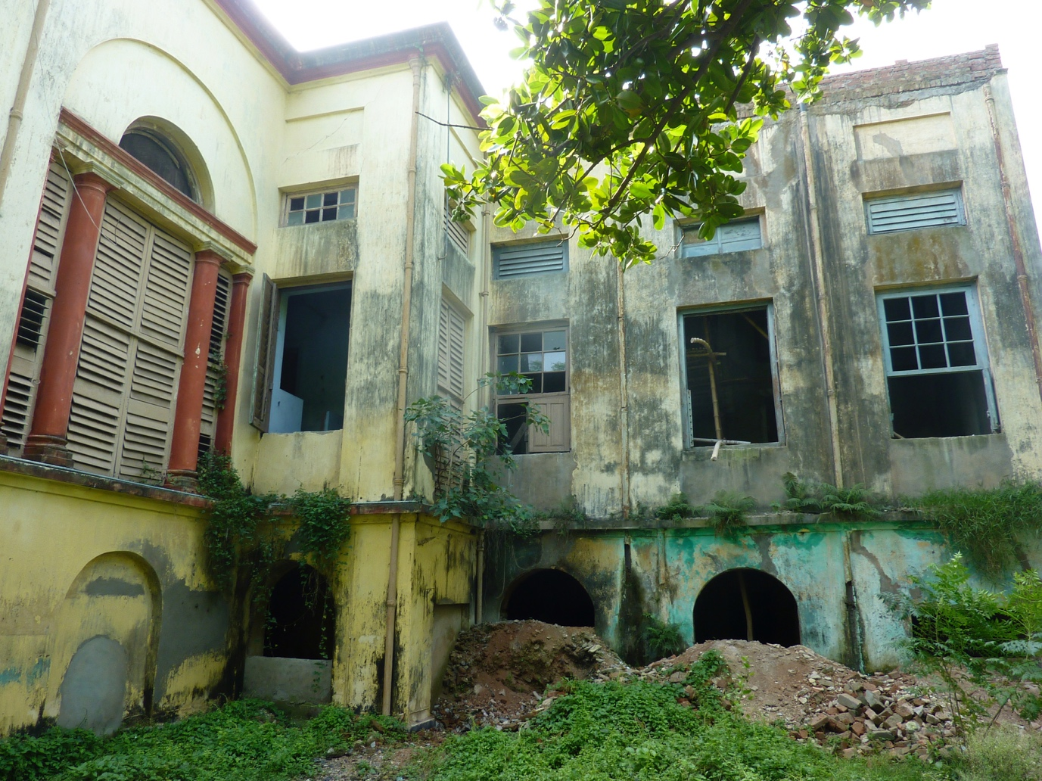

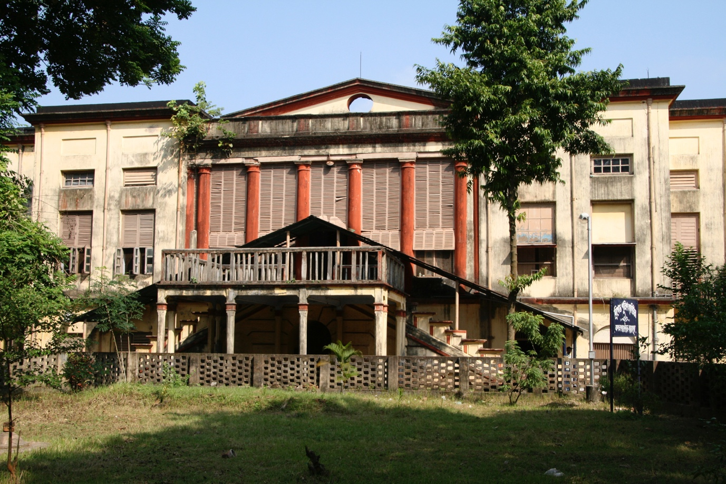

*Former Government House, Barrackpore; now a derelict ruin*

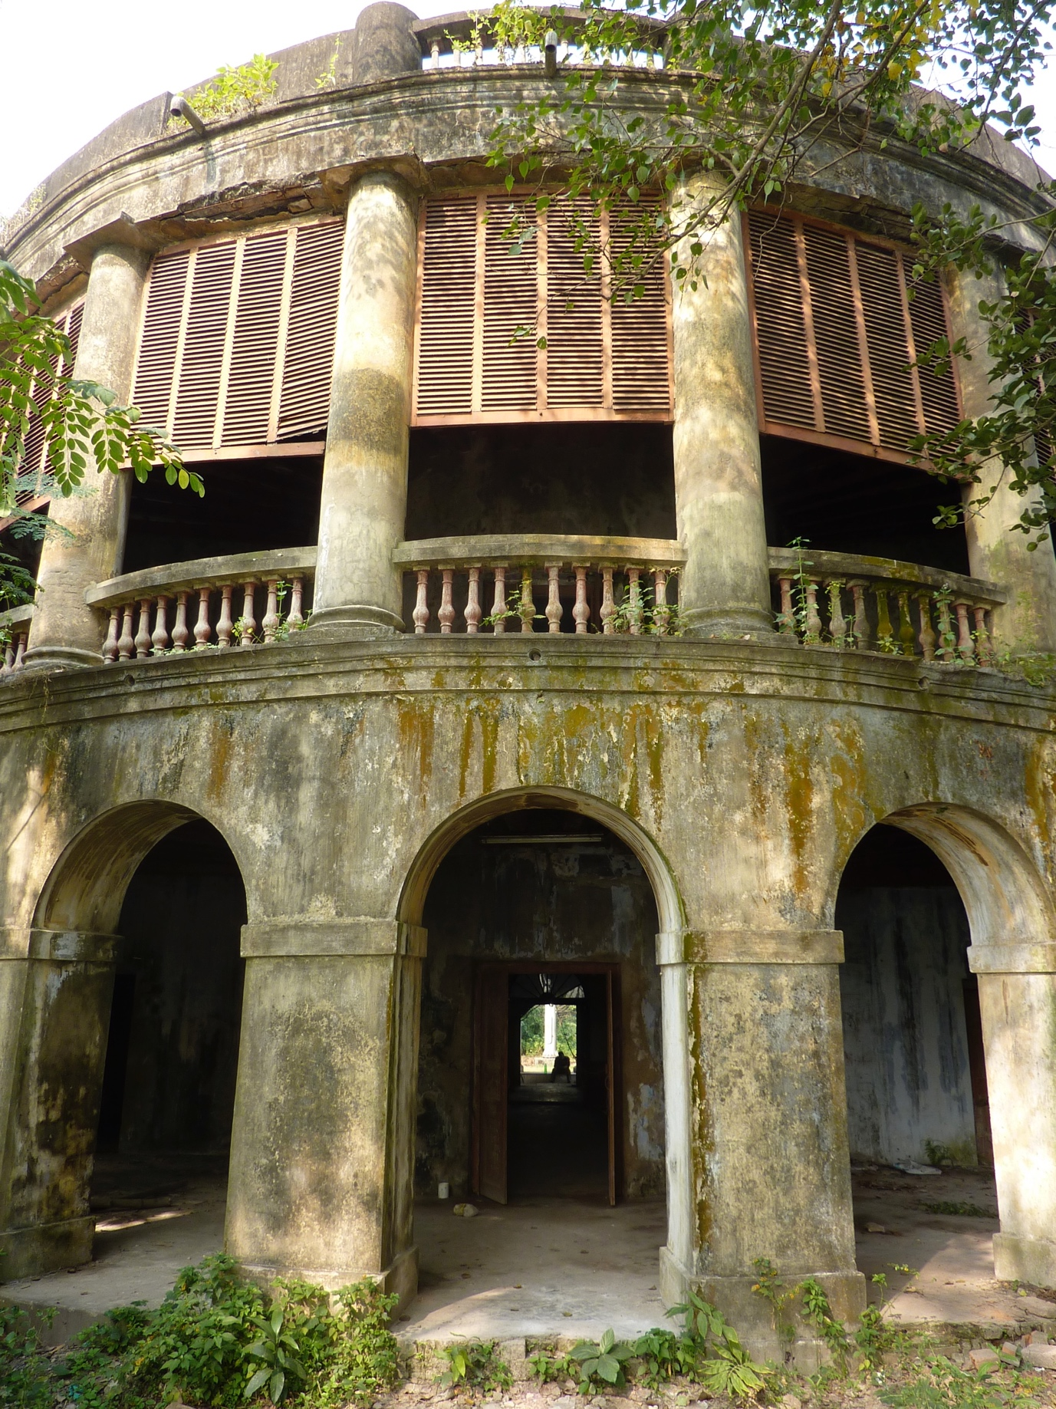

*The Roxburgh building, Botanical Gardens, Kolkata; a site of world significance*

This report is the copyright of Philip Davies (Heritage and Planning) Ltd and is for the sole use of the person/organization to which it is addressed. Philip Davies (Heritage and Planning) Ltd is a limited liability company registered in England no: 07746718. Registered office: 51 Clarendon Court, Finchley Road. London NW11 6AD e mail : [phd51@btinternet.com](mailto:phd51@btinternet.com)

March 2016